**MBFS P.E. UNIFORMS**

* **Beginning in the Fall of 2024, all middle 6-8 students will be required to wear only school approved uniforms for Physical Education class. *Please read size chart before ordering, as there will be NO refunds. See size charts below.**

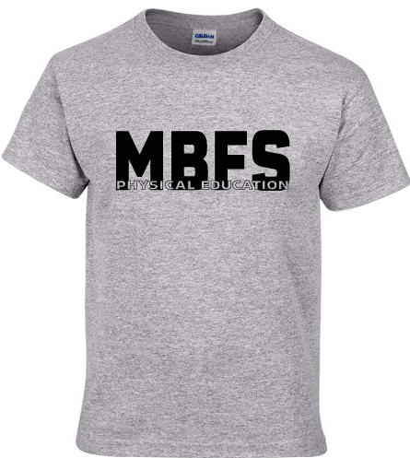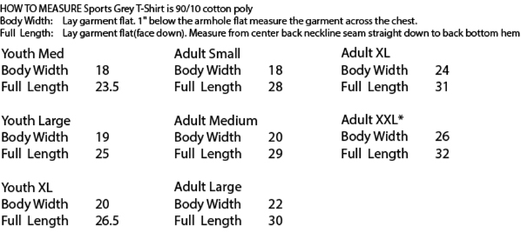

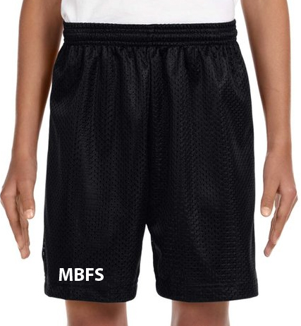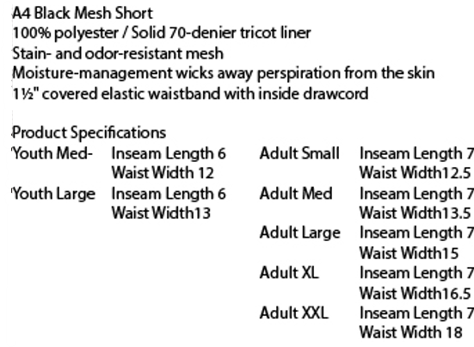

* **To purchase the P.E. Uniforms, go to** [**https://pcsb.revtrak.net/multi-grade/#/list**](https://pcsb.revtrak.net/multi-grade/#/list)**.**

Shirts (Small to X-Large) = $10.00 / Shirts (XX-Large) = $14.00

Shorts ((Small to X-Large) = $10.00 / Shorts (XX-Large) = $14.00